13/3/2021

Harvey Merton

Mechatronics engineering student

Project Portfolio

Table of Contents

Design and manufacture oriented 2

Project 1 – Bedside table 2

Project 2 – Tax returns assistant programme 3

Project 3 – Wardrobe 4

Project 4 – General machining 5

Project 5 – F:SAE maps importer 6

Project 6 – EG Whiter oil box and vise booster 7

Oil box 7

Vise booster 8

Project 7 – F:SAE upright bracket testing jig 9

Project 8 – M019 gearboxes 10

Project 9 – Warman design and build competition robot 11

Project 10 – M020/M021 F:SAE Chief Engineer 11

Project management and systems 12

3D printed Ti64 brackets: design and manufacture 14

Fully parametrically modelled cooling jackets **Error! Bookmark not defined.**

Project 11 – Autonomous F:SAE car 15

Research, communication and presentation oriented 16

Project 1 – Eureka science communication competition 16

Project 2 – Monetary policy challenge 16

Project 3 – Thropy debating 17

Project 4 – F:SAE business presentation 17

Project 5 – F:SAE Chief Engineer Presentations 17

# Design and manufacture oriented

## Project 1 – Bedside table

**Date:** 2013-2014

**Type:** Mechanical design and manufacture - carpentry

**Learnt:** Basic design and measurement. How to use various woodworking hand and machine tools. How to manufacture different types of joints (e.g. dovetail). Finishing techniques.

**Pictures:**

## Project 2 – Tax returns assistant programme

**Date:** 2016-2017

**Type:** Software design and coding

**Learnt:** How to design and build software. How to search for help and overcome software problems. Practical implementation of Object Oriented programming (OOP) in Java. How to build a graphical user interface (GUI). Basic communication with client regarding needs.

**Pictures:**

## Project 3 – Wardrobe

**Date:** 2019

**Type:** Mechanical design and manufacture – carpentry

**Learnt:** Identification of some types of wood. Processes to recycle and refurbish old materials. How to use more complex machine tools for woodworking (e.g. mill). How to select tools and processes based on needs. Manufacture design.

**Pictures:**

## Project 4 – General machining

**Date:** 2018 - present

**Type:** Mechanical design and manufacture - metalworking

**Learnt:** How to perform basic metalworking tasks on the mill and lathe. Hand tools for metalworking. Basic TIG welding. Interpreting mechanical drawings. Devising manufacture methods and managing manufacture. Teaching practical tasks to others.

**Pictures:**

Note: Placeholder picture only (made a similar part but took no pictures).

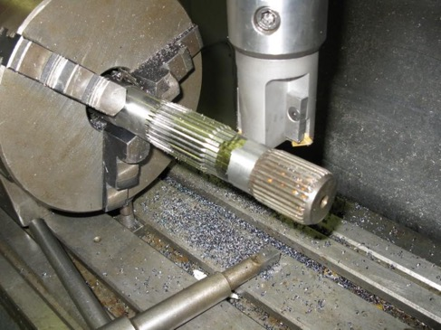

## Project 5 – F:SAE maps importer

**Date:** Late 2018 – early 2019

**Type:** Software and algorithm design and coding

**Learnt:** Using MATLAB to solve a complex, open-ended problems. How to use vectors in programming applications. Integrating software with pre-existing software. Using MATLAB toolboxes.

**Pictures:**

## Project 6 – EG Whiter oil box and vise booster

**Date:** Early 2019

**Type:** CAD design and CNC manufacture

**Learnt:** How to perform proper parametric design in Creo Parametric. CNC machine programming, setting and operation. Full practical mechanical design including design for manufacture. Routine (oil box) and non-routine (vise booster) design.

**Pictures:**

### Oil box

### Vise booster

## Project 7 – F:SAE upright bracket testing jig

**Date:** Early 2019 - present

**Type:** CAD design, mechanical drawings, manufacture management.

**Learnt:** Design for testing. Producing drawings in Creo Parametric. How to specify requirements and communicate methods to inexperienced machinists. Teaching manufacture.

**Pictures:**

## Project 8 – M019 gearboxes

**Date:** Early 2019 - present

**Type:** Manufacture design and management

**Learnt:** Communication for manufacture. Making effective timelines and budgets for a multi-thousand-dollar critical subsystem. Effective team and outsourcing communication and collaboration. Delegation.

**Pictures:**

## Project 9 – Warman design and build competition robot

**Date:** Early 2019 - present

**Type:** Mechatronics design and manufacture.

**Learnt:** Practical electronics design, wiring and soldering. How to use an Arduino microcontroller and motor controllers. How to use a laser cutter. How to perform mechanical design in a team.

**Pictures:**

**

## Project 10 – M020/M021 F:SAE Chief Engineer

**Date:** Mid 2019 – Feb 2021 (one of the longest serving Chief Engineers)

**Type:** Integration, management and mechanical design.

**Learnt:** How to manage a design team. Establishing higher-level design goals

### Project management and systems

Autodesk Vault  
  
Systems design and integration   
  
3D printed Ti64 brackets: design and manufacture

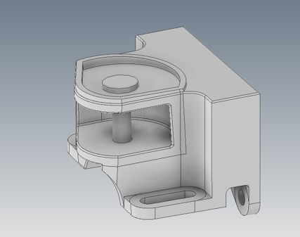

Project 11 – Autonomous F:SAE car  
**Date:** 2021

**Type:** Research and mechatronics design

**Learnt:**

**Pictures:**

(See other report)

Research, communication and presentation oriented

## Project 1 – Eureka science communication competition

**Date:** 2015

**Type:** Science and business communication

**Learnt:** How to establish a sound business case. How to communicate scientific knowledge to a non-scientific audience. Applying scientific knowledge to a novel design. Answering scientific application questions.

**Pictures:**

<https://www.youtube.com/watch?v=rkIjMVVjMQ4>

## Project 2 – Monetary policy challenge

**Date:** 2017

**Type:** Business and economics communication.

**Learnt:** How the world economy works and what role legislation plays in this. How to research current economic facts and produce a succinct business case. Managing a team of presenters. How to verbally integrate contributions and answer economic questions.

**Pictures:**

## Project 3 – Thropy debating

**Date:** 2018

**Type:** Debating

**Learnt:** How to present a logical and well-reasoned argument. Improvisation and thinking on the spot. Preparation under time-pressure.

## Project 4 – F:SAE business presentation

**Date:** 2018 & 2019

**Type:** Business pitch and management consulting.

**Learnt:** How to pitch an engineering design to a varied audience. How to manage research. Incorporating humour for dramatic effect.

**Pictures:**

## Project 5 – F:SAE Chief Engineer Presentations

**Date:** 2020 & 2021

**Type:** Engineering design reviews and sponsor pitches

**Learnt:** How to present engineering designs for review, how to present to sponsors to entertain and inspire cash flow.

**